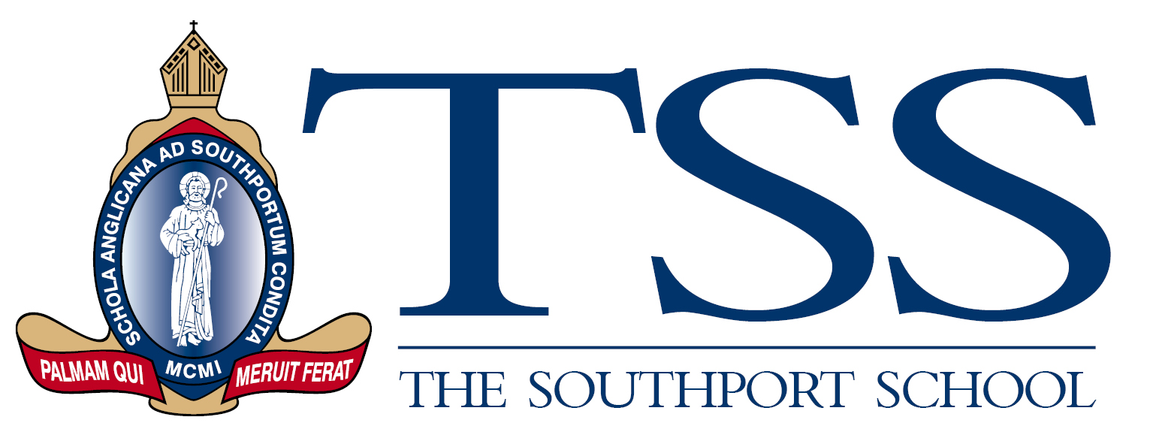

**Deputy Head of Senior School – Pastoral Care**

The Southport School is a leading Anglican Day and Boarding School for boys situated on the banks of the Nerang River in the heart of the Gold Coast.  The Southport School (TSS) has been established for 121 years and is committed to providing excellence in leadership, learning and teaching, pastoral care, and extra-curricular endeavours within a balanced, holistic Christian environment.  The School has a vibrant boarding, academic, cultural and sporting program that extends across the full year and two campuses.

At TSS, our students and staff reach their full potential in a safe environment of respect, and genuine caring. In partnership with families and our alumni, we challenge and support our students to become men who balance confidence with compassion. We contribute to the community and foster global citizens in the Anglican tradition and to help us achieve this, we are recruiting for a newly established **Deputy Head of Senior School – Pastoral care** role to start the 2024 school year.

As a member of the School Executive team, the role will work closely with the Deputy Headmaster -Head of Senior School and the Deputy Headmaster – Head of Learning and Teaching.

The successful candidate will demonstrate strong emotional intelligence, compassion, empathy, and a focus on optimal pastoral outcomes in the context of the holistic wellbeing of the boys. The position requires an excellent communicator, both verbal and written, who can engage the entire community including students, parents, alumni, and staff.

In support of our School values of **Teamwork, Scholarship, and Service**, we are seeking candidates who are relational in their management style, with experience in a boarding setting considered highly beneficial as would candidates who have a passion for boys’ education and who understand how to engage with boys to ensure they feel valued and are encouraged to develop their academic, wellbeing, spiritual, sporting and cultural talents.

All staff at The Southport School should be supportive of the Anglican Code of Conduct and stated values and Christian Ethos of the School. Candidates must be eligible for, or hold current Queensland Teacher Registration, submit to an Anglican Diocese National Register check. Candidates will be asked to provide a recent national criminal history check.

For further information about the position, including a detailed position description and to apply, please see the [TSS website](https://www.tss.qld.edu.au/discover/employment-opportunities).

All applications must include a current CV and a 1-page statement that outlines the knowledge, skills and attributes that you would bring to the role and they must be submitted online by **Monday 23 October at 4pm.**.

Candidates should address applications and questions to the People and Culture Manager, The Southport School via email [Kirsty.payne@tss.qld.edu.au](mailto:Kirsty.payne@tss.qld.edu.au)

***TSS is an equal employment opportunity employer***