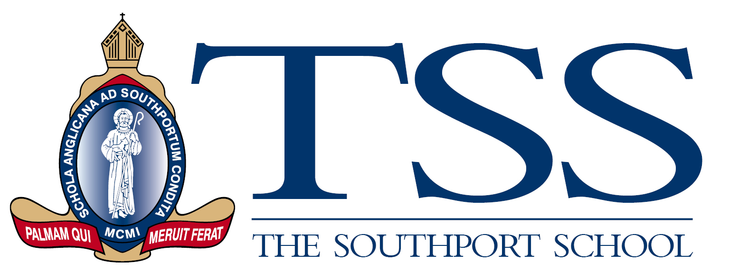

**Library Technician – Senior Campus**

**Full time, term time + 4 weeks per annum**

The Southport School is a leading Anglican Day and Boarding School for boys situated on the banks of the Nerang River in the heart of the Gold Coast.  The Southport School (TSS) has been established for 122 years and is committed to providing excellence in leadership, learning and teaching, pastoral care, and extra-curricular endeavours within a balanced, holistic Christian environment.  The School has a vibrant boarding, academic, cultural and sporting program that extends across the full year and two campuses.

Our Senior Library team are now **seeking an experienced and enthusiastic** **Library Technician** to join our senior school library with an immediate start available. This role will be responsible for assisting our students and teachers with accessing and utilising library resources effectively as well as managing the organisation of books, digital media, and databases, facilitating checkouts, and supporting information inquiries. Candidates should hold a Cert III in Library and Information services as a minimum qualification, Cert IV or Diploma level would be considered highly beneficial coupled with experience working in educational or high use library settings.

This is a full time, term time plus 4 weeks (school holiday time) per annum role with workings hours from 8.00am to 4.00pm daily. Specifically, we are seeking candidates who will assist with:

* **Resource Management**: Organising and cataloguing library materials, including books, periodicals, audiovisual resources, and digital content, to ensure easy access for students and teachers.
* **Student and Staff Assistance**: Assisting students and staff in locating and utilizing library resources, offering guidance on research techniques, and helping with information inquiries.
* **Circulation Services**: Managing the circulation desk, processing book checkouts and returns, issuing library cards, and maintaining accurate records of borrowed materials.
* **Technology Support:** Maintaining and troubleshooting library technology, such as computers, printers, and online databases, to ensure smooth access to digital resources.
* **Library Programs**: Collaborating with teachers to support curriculum needs, organising library events, promoting literacy initiatives, and fostering a reading-friendly environment within the school community.

If you are organized, knowledgeable, love to collaborate and provide a high level of service and support to our school community through your love of libraries and learning, then we would love to hear from you! If would like to know more about TSS, please visit our webpage at [www.tss.qld.edu.au](http://www.tss.qld.edu.au), click on our ‘Discover’ menu and check out our team!

Importantly, all staff at The Southport School are asked to be supportive of the stated values and Anglican Ethos of the School, the adhere to the Code of Conduct and must hold a current Blue Card or be eligible to apply for one. Candidates will be required to submit their details for a national register check conducted by the Anglican Schools Professional Standards office and must hold a Federal Police check certificate.

Only applications submitted online will be considered and close on **Friday 13 October 2023 at 4pm.**Only applications submitted online will be considered and applications should be submitted to:

People and Culture Manager

The Southport School

2 Winchester Street

Southport, QLD 4215

***TSS is an equal employment opportunity employer***